**The Papas and The Mamas**

**CONTRACT RIDER 2019**

This rider is hereby made part of the contract to which it is attached. By executing the face of said contract, Purchaser evidences his/her agreement to fulfill the terms contained in this rider. Purchaser's failure to execute this rider by signing it in the spaces provided below shall not release him/her from his/her obligations as set forth hereunder.

**PURCHASER AGREES TO PROVIDE THE FOLLOWING AT NO COST TO ARTIST:**

**I. BILLING/ADVERTISING**

1. The correct billing for Artist as follows: 100%  **The Papas and The Mamas**

2. Purchaser agrees that he will not commit the Artist to any appearances, interviews, or any type of promotional activities without prior written consent.

2.A **No old stock photos or old versions of The Papas and The Mamas music and live footage are to be used in promotion of the group.** Only photos, music, or live footage approved and supplied by TCI or The Papas and The Mamas are to be used in the promotion of this event.

**PLEASE ALERT YOUR WEBMASTER!!!!!!!!!**

**II. ARTIST ACCOMMODATIONS**

3. One (1) private and comfortable dressing room large enough to hold nine (9) people. Dressing room shall be clean and well lit, and shall contain at least nine (9) chairs, one (1) large mirror, nine (9) large, clean, dry towels and a clothes rack with hangers. The dressing room shall be within easy access to clean, well maintained rest rooms that are serviced by hot and cold running water and standard electrical outlets.

4. Dressing room MUST be lockable or have security guards posted at all times. Room must have a minimum of one (1) 110V A.C. outlet that is operative. Purchaser shall be solely responsible for the security of all items in the dressing rooms and shall keep all unauthorized persons from entering dressing room/backstage area.

5. Artist reserves the right to approve who is allowed in the backstage and dressing room areas.

6. Adequate parking for several vehicles.

**III. HOSPITALITY**

7. The following items shall be placed in Artist's dressing room at the time designated by Artist's Road Manager):

1) One (1) deli trays of cold cuts, cheese and crackers

2) Six (6) cans of cold Diet Coke and Regular Coke, Two (2) Cans of no sugar Red Bull

3) Hot coffee and Tea

4) Minimum five (5) quarts of bottled water

1. **PRODUCTION REQUIREMENTS**

8. Professional lighting, monitor and sound reinforcement systems as specified in the attached Spec List and Stage Plan, with professional technicians, stage hands and loaders.

9. A sound check, including a vocal monitor check, will be conducted at least two (2) hours prior to performance to insure proper settings.

**V. BACKLINE EQUIPMENT (WHEN APPLICABLE)**

See tech rider for back line info

**The Papas and The Mamas RIDER**

**PAGE 2**

**VI. INSURANCE**

10. Purchaser agrees to provide full insurance coverage to protect against injuries to person or property as a consequence of the installation and/or operation of the equipment provided or used by the Artist, the contracted sound company and the contracted lighting company.

**VII. ARTIST GUEST LIST**

11. Six (6) complimentary tickets per show must be given to Artist. In the case of local support, no more than one comp per band member shall be allowed.

**VIII.** **AUDIO/VISUAL RECORDING**

12. **Purchaser hereby acknowledges and confirms that under no circumstances shall there be audio or video taping or the broadcast of any kind, via any method, means or media, of any part of Artist’s performance hereunder**. Any attempt to audio or video tape or broadcast any portion of Artist’s performance directly or indirectly by Purchaser, his/her agents, employees, subcontractors, etc. or by any audience member or any third party, will automatically render this Agreement null and void, except that Purchaser shall remain liable to Artist for the compensation guaranteed to Artist hereunder, plus damages and reasonable attorney’s fees in respect of the unauthorized taping and or broadcast.

**IX. PRESENTATION OF PERFORMANCE**

13. Purchaser agrees that Artist will be held completely and wholly harmless for any damages incurred to the facility and/or its furnishings, and for any injury to any audience or staff members by any of the audience prior to, during or after the performance.

14. Artist reserves the right to approve any and all opening and support acts, as well as the budget for these acts.

15. In the case of any conflict of terms, the terms contained in this rider shall prevail over any other terms including printed, handwritten or typed terms located elsewhere in the contract. Purchaser specifically accepts all terms of this rider unless Artist waives them. Such waiver shall only be effective if initialed by both Artist (or representative) and Purchaser.

**X. FACSIMILE SIGNATURES**

27. This agreement may be executed by copies transmitted by telecopiers, each of which shall be given the same force and effect as the original.

AGREED TO AND ACCEPTED BY: AGREED TO AND ACCEPTED BY:

____________________________________ __________________________________________

ARTIST PURCHASER

##### The Papas and The Mamas SUPPLEMENTAL RIDER

# TRAVEL AND HOTEL ACCOMODATIONS (WHEN APPLICABLE)

This rider is hereby made part of the contract to which it is attached. By executing the face of said contract, Purchaser evidences his/her agreement to fulfill the terms contained in this rider. Purchaser's failure to execute this rider by signing it in the spaces provided below shall not release him/her from his/her obligations as set forth hereunder. A TCI Representative must approve any changes or deletions to this rider.

**PURCHASER AGREES TO PROVIDE THE FOLLOWING AT NO COST TO ARTIST:**

1. ~~Eight (8) round-trip direct airfares to the venue city as follows: six (6) from New York and two (2) from Chicago (unless otherwise specified in the attached contract). Artist must approve all flights prior to ticketing.~~
2. All internal ground transportation including transfers between the airport, hotel and venue. Vehicle must accommodate eight (8) people with luggage comfortably (unless otherwise specified in attached contract).
3. Eight (8) hotel rooms for up to two (2) nights(unless otherwise specified in attached contract).

AGREED TO AND ACCEPTED BY: AGREED TO AND ACCEPTED BY:

____________________________________ __________________________________________

ARTIST PURCHASER

**The Papas and The Mamas - Stage Plot - 2019**

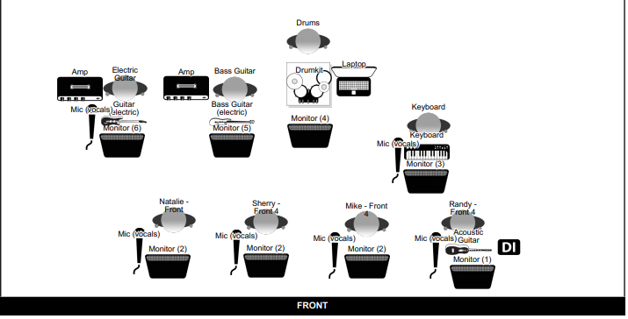

**MONITORS**

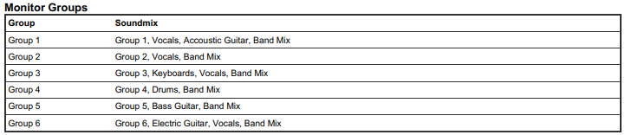

**BACKLINE REQUIREMENTS**

**KEYBOARDS**

1. One (1) Keyboard monitor wedge or amplifier (1x12 each) and one (1) sustain pedal for keyboard.

2. One (1) double keyboard stand

3. One (1) drum stool, with back

4. One (1) Roland 700 or Kurtzweil PC 88 (MX), for bottom keyboard

5. One (1) Korg Triton or Yamaha Motif ES or XS, any series 61 keys, for top keyboard

6. One (1) Boom mic for keyboardist vocals

**BASS**

1. One (1) Ampeg bass head with one (1) 2x12 Ampeg bass cabinet, or comparable model

2. One (1) Guitar stand

**GUITARS**

1. One (1) Fender Deluxe Reverb 1x12, with footswitch, or any Fender tube amp over 60 watts

2. One (1)Guitar stand

3. One (1) Boom mic for guitarist vocals

**DRUMS**

1. **One (1) Drum kit** (Gretsch USA Custom or DW Collectors Series preferred), to include:

10” and 12” rack toms (on bass drum mount), 14” and 16” floor toms (on legs), 22” kick drum,

(1) wood snare drum, (1) metal snare drum (5” to 6” deep; no deep-shell models).

2. **Drum hardware** (DW preferred) to include: (1) 9000 or 5000 double pedal, (2) snare stands, (1) hi-hat

stand with rotating tripod, (4) boom cymbal stands, throne with back.

3. **Cymbals:** (Sabian or Zildjian preferred) to include: 20” ride (medium to heavy), 16”, 17”, and 18”

crashes (thin to medium), and 13” (preferred) or 14” hi-hats (medium).

4. **Drum Riser:** **MINIMUM** 6’ x 6’; **PREFERRED** 8’ x 8’

**OTHER REQUIREMENTS (2019)**

** Front 4 singers need 3 straight mic stands and 1 Boom mic stand

**Channel List**

